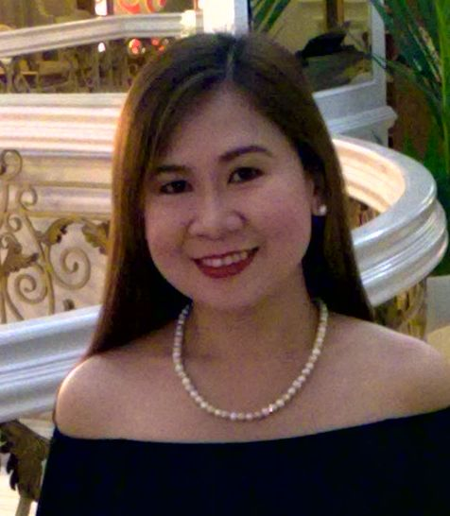
Menchie

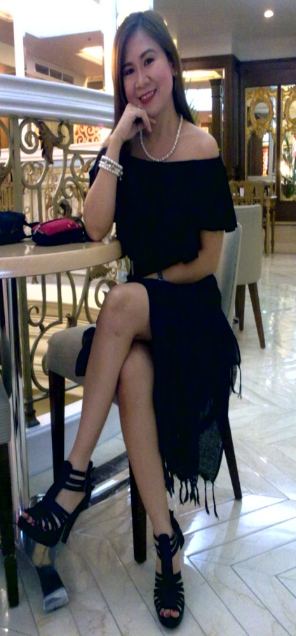
MENCHIE GONZALES –PROFESSIONAL SINGER / VOCALIST, WAS A MEMBER / FOUNDER OF THE FORMER MILLENNIUM BAND NAMED “MAHA”. SHE’D BEEN IN SOME KEY CITIES IN ASIA AND MIDDLE EAST AS AN ARTIST-PERFORMER, WITH MAHA BAND FOR ALMOST A DECADE, BEFORE THEY RECORDED THEIR FIRST ALBUM TITLED “MAHA”. SHE WROTE FOUR SONGS IN THE ALBUM. MENCHIE CAN DANCE WHILE SHE SINGS.
MENCHIE’S WORK EXPERIENCE IS AS FOLLOWS:
HOTEL AND RESORT- ZAMBIA,AFRICA AS VOCALIST
RAMADA RENNAISSANCE HOTEL-MALAYSIA---AS VOCALIST
HOTEL IMPERIAL-SINGAPORE----AS VOCALIST
GOLDEN LANDMARK HOTEL—SINGAPORE—AS VOCALIST
ATLAS HOTEL-BAHRAIN----AS VOCALIST
CAIRNHILL HOTEL—SINGAPORE—AS VOCALIST
MISS CHOICE CLUB—FUKUOKA CITY,JAPAN—AS VOCALIST
MAJAN HOTEL—OMAN-AS VOCALIST
SCORPIO LOUNGE—ROTANA HOTEL,ABU DHABI,UAE—AS VOCALIST
WENT HOME TO RECORD A DEBUT ALBUM-DISTRIBUTED BY IVORY RECORDS
HAD A STINT IN PRESIDENT’S HOTEL,MAHARLIKA LOUNGE,DUBAI
DID SOME TV GUESTINGS,CONCERTS AND GIGS IN VARIOUS BARS,HOTELS AND RESTOS IN METRO-MANILA.
PERFORMED IN AL-AIN PALACE HOTEL,ABU DHABI AS AN ACOUSTIC SINGER.
Performed at Al-Wadi Hotel OMAN.

Local bookings:
Performed at Net World Hotel ( Pagcor Club Majestic )
Pagcor Ronquillo ( Pavillion) and Taal Vista Hotel Tagaytay.
Heritage hotel-Pagcor, Binondo Casino Arcade., Hyatt Hotel, Pearl Manila Hotel, Pan Pacific hotel
Net world Hotel, Pagcor casino tagaytay.
Menchie’s Contact numbers: +63939-5355986, +63916-7645649 , (02) 5655567.

