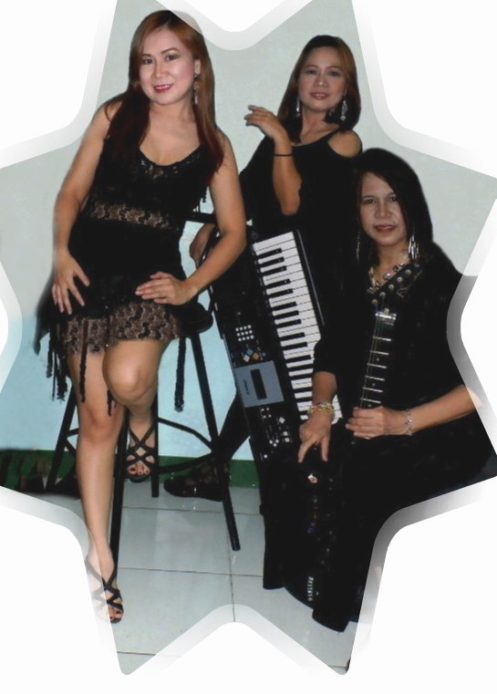
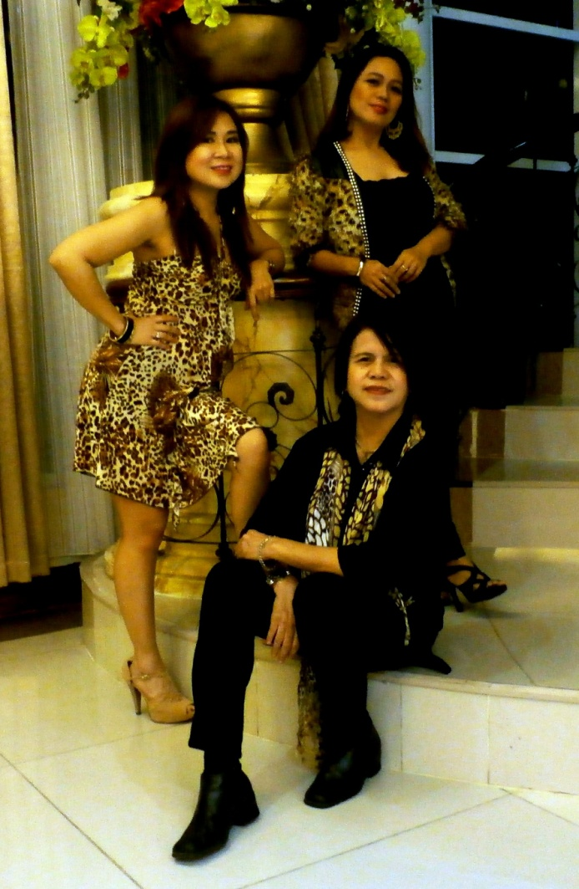
Maha Band
For more information, contact details of MAHA Band
Mobile +63939-5355986 / +63916-7645649
+639064314989 / +63919-8592831…..Tel: +632- 5655567 - Philippines
Email add: chiekulitz23@yahoo.com
darlingbabes2003@yahoo.com
Maha band is consisting of three ladies who are also members of the millennium recording band called MAHA BAND “Menchie And Her Acts”.
They have been invited to some TV channels such as GMA 7- Walang Tulugan and channel 13, Alas Dose sa Trese. and 2nd Avenue, Rj Tv Destiny channel. They just finished their concert last October 4, 2014 at Dusit hotel, RJ bistro.
Maha band has already traveled and performed in some key cities of southeast Asia namely; Malaysia, Singapore & Japan. And in some open countries in middle east like Bahrain, Oman, Abu Dhabi, Dubai and their last stint was in the continent of Africa.
Maha band is composed of…Carmencita Gonzales, a.k.a.“menchie” as lead vocalist and percussionist and founder of the group.
Claire B. Gumban,a.k.a.“babes”, as guitarist / keyboardist sequencer and also a vocalist. And Marilou San Jose a.k.a. “tata” as keyboardist and also a vocalist.

After the release of their debut album titled “Menchie And Her Acts”, the Maha band decided to go acoustic and sequencer band. Years ago…. They started making waves in several bars, restaurants and Hotels or watering holes in Metro-
Manila such as in; San Mig, Chaquicos bar, Abas grill, Niche bar, Voda bar, Jumbo
kingdom, Chakik’s bar, Farmers plaza, SM malls, Jam’s bar, La falooka bar, Cowboy grill lite, Conggo grill, Lory’s lounge, Dampa farmers market ,Casino Filipino, Pan-Pacific Hotel , Pearl Manila Hotel, Pagcor Tagaytay and Heritage Hotel, Hyat hotel , Net World Hotel, Pagcor Club Ronquillo ,Taal Vista Hotel,Tagaytay. Binondo Casino arcade and Hotel Resort, Zambia Africa.
******* Maha trio are ready for bookings local and abroad.
Their work experiences are as follows:
CARMENCITA ’’MENCHIE” GONZALES
VOCALIST,PERCUSSIONIST. SHE WAS A MEMBER / FOUNDER OF THE FORMER MILLENNIUM BAND NAMED ‘MENCHIE AND HER ACTS”. SHE’D BEEN IN SOME KEY CITIES IN ASIA AND MIDDLE EAST AS AN ARTIST-PERFORMER FOR ALMOST A DECADE, BEFORE THEY RECORDED THEIR FIRST ALBUM TITLED “MENCHIE AND HER ACTS”. SHE WROTE FOUR SONGS IN THE ALBUM. She can also dance while she sings.
MENCHIE’S WORK EXPERIENCE IS AS FOLLOWS:
Dec to present 2015---concerts and functions,Metro-Manila, and pagcor Hyatt.
October 4, 2014- concert at Dusit hotel , RJ Bistro
September 2014- Hyatt Hotel and Casino
September 2014- Madison Square casino
Oct- December 2013- Hyatt hotel
DECEMBER 2012- 2013 Binondo Casino Arcade.
December 2011 to August 2012- Hotel Resort, Zambia Africa
November to March 2011- Pagcor club ronquillo and Taal vista Hotel ,Tagaytay
MAY 2010 TO SEPT performed at Net World Hotel ( Pagcor Club Majestic )
November 2008 to May 2009- performed at Al-Wadi Hotel OMAN.
2007- --PERFORMED AT PAN PACIFIC HOTEL, PAGCOR-CASINO TAGAYTAY, HERITAGE HOTEL AND PEARL MANILA HOTEL. .
2006----PERFORMED IN AL-AIN PALACE HOTEL,ABU DHABI.
2002-2005—DID SOME TV GUESTINGS,CONCERTS AND GIGS IN VARIOUS BARS,HOTELS AND RESTOS IN METRO-MANILA.
2001---- HAD A STINT IN PRESIDENT’S HOTEL,MAHARLIKA LOUNGE,DUBAI
2000--- WENT HOME TO RECORD A DEBUT ALBUM-DISTRIBUTED BY IVORY RECORDS
1999----- SCORPIO LOUNGE—ROTANA HOTEL,ABU DHABI,UAE—AS VOCALIST
1999—-- MAJAN HOTEL—OMAN-AS VOCALIST
1998----- MISS CHOICE CLUB—FUKUOKA CITY,JAPAN—AS VOCALIST
1996-97- CAIRNHILL HOTEL—SINGAPORE—AS VOCALIST
1995----- ATLAS HOTEL-BAHRAIN----AS VOCALIST
1994----- GOLDEN LANDMARK HOTEL—SINGAPORE—AS VOCALIST
1992-93- HOTEL IMPERIAL-SINGAPORE----AS VOCALIST
1992—--- RAMADA RENNAISSANCE HOTEL-MALAYSIA---AS VOCALIST

CLAIRE ’BABES’ GUMBAN—LEAD AND RHYTHM GUITARIST/ KEYBOARDIST/ PIANIST- SEQUENCER , ALSO DOES THE VOCALS AND HARMONY .BABES PENNED SIX SONGS IN THE ALBUM OF -- MENCHIE AND HER ACTS. BABES ALSO TRAINS BEGINNERS IN MUSIC,PARTICULARLY GUITAR,DRUMS,KEYBOARDS AND PERCUSSIONS.
WORK EXPERIENCE OF BABES:

Dec to present 2015---concerts and functions,Metro- Manila
October 4, 2014- concert at Dusit hotel , RJ Bistro
September 2014- Hyatt Hotel and Casino
September 2014- Madison Square casino
Oct- December 2013- HYATT HOTEL & MADISON CASINO
DECEMBER 2012- 2013 Binondo Casino Arcade.
December 2011 to August 2012- Hotel Resort, Zambia ,Africa- keyboardist/guitarist
November to March 2011- Pagcor club ronquillo and Taal vista Hotel ,Tagaytay.
MAY 2010 TO SEPT- Net World Hotel ( Pagcor Club Majestic )
November 2008 to May 2009- performed at Al-Wadi Hotel OMAN.
2007 = PERFORMED AT PAN PACIFIC HOTEL, PAGCOR-CASINO TAGAYTAY, HERITAGE HOTEL AND PEARL MANILA HOTEL.
2006 –---PERFORMED N AL –AIN PALACE HOTEL WITH MENCHIE AS AN ACOUSTIC BAND
2002-05- HAD SOME STINTS WITH MENCHIE AS AN ACOUSTIC GROUP.
2001------PERFORMED IN MAHARLIKA,PRESIDENT’S HOTEL,DUBAI.
2000------WROTE SIX SONGS AND RECORDED AN ALBUM WITH MENCHIE.
1999------SCORPIO LOUNGE-ROTANA HOTEL—ABU DHABI,UAE
1999------MAJAN HOTEL—OMAN—AS GUITARIST-SINGER
1998------MISS CHOICE,FUKUOKA CITY,JAPAN—AS SINGER-GUITARIST
1996-97-CAIRNHILL HOTEL—SINGAPORE-AS SINGER-LEAD GUITARIST
1995------ATLAS HOTEL-BAHRAIN-AS SINGER-LEAD GUITARIST
1994------GOLDEN LANDMARK HOTEL—SINGAPORE—AS LEAD GUITARST- SINGER
1993-------HOTEL IMPERIAL-SINGAPORE—AS LEAD GUITARIST-SINGER
1992- -----RAMADA HOTEL-MALAYSIA—AS GUITARIST-SINGER

MARILOU ”TATA” SAN JOSE –KEYBOARDIST AND ALSO DOES THE VOCALS AND HARMONY. TATA WAS A FORMER ORIGINAL MEMBER OF RECORDING BAND CALLED MAHA BAND.
WORK EXPERIENCE OF TATA
Dec to present 2015---concerts and functions,Metro- Manila
October 4, 2014- concert at Dusit hotel , RJ Bistro
September 2014- Hyatt Hotel and Casino
September 2014- Madison Square casino
1999------SCORPIO LOUNGE-ROTANA HOTEL—ABU DHABI,UAE-KEYBOARDIST
1999------MAJAN HOTEL—OMAN—AS KEYBOARDIST-SINGER
1998------MISS CHOICE,FUKUOKA CITY,JAPAN—AS SINGER-KEYBOARDIST
1996-97-CAIRNHILL HOTEL—SINGAPORE-AS SINGER- KEYBOARDIST
1995------ATLAS HOTEL-BAHRAIN-AS SINGER- KEYBOARDIST

